We want to tell you…..

*Collecting your thoughts, opinions and views for an EHC Assessment Request*

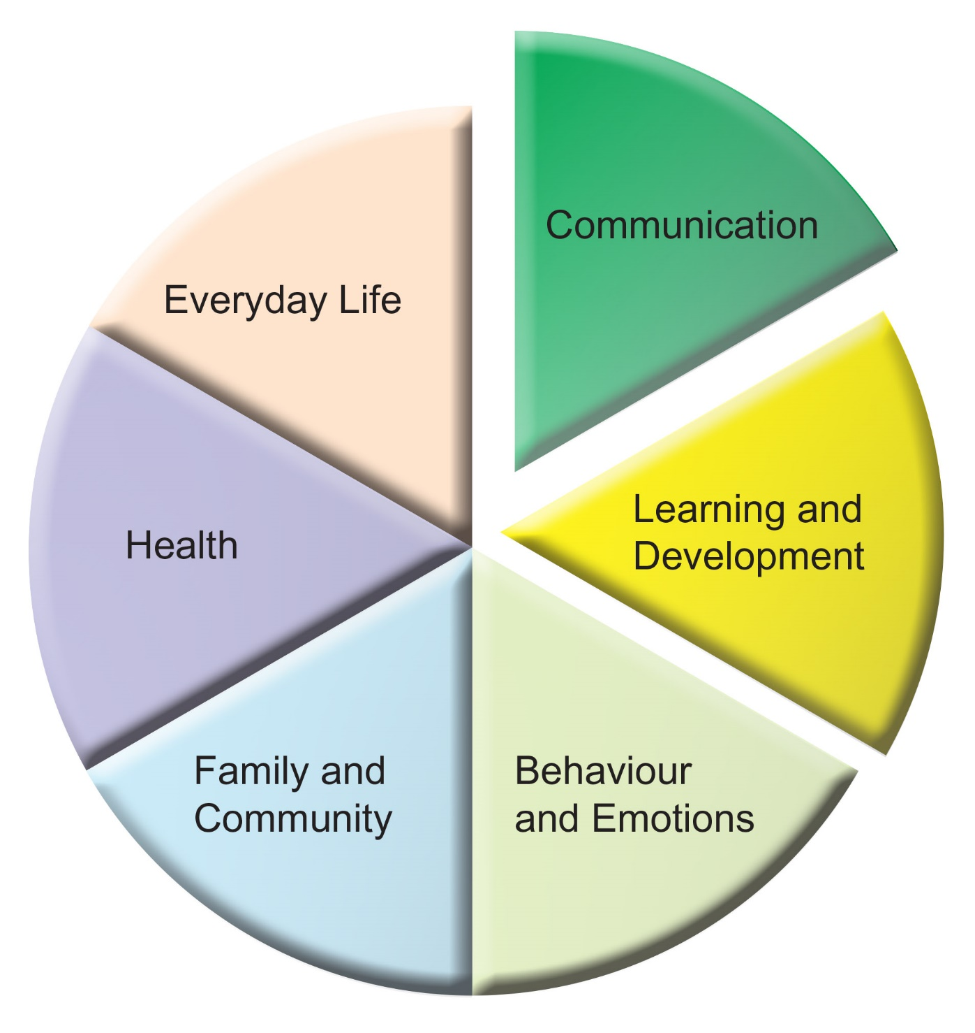

Name of Child/Young Person ………………………………………………………………....

Name of person completing this form …………………………………………………………

Date of Birth………………………………………………………………………………………

Address………………………………………………………………………………………………………………………………………………………………………………………………...…

Parents’/Young Person’s

preferred contact details………………………………………………………………………..

We want to tell you.....

Collecting your thoughts, opinions and views for an EHC Assessment Request.

Guidance

This document can be used to tell us about your child’s special educational needs. It will be a part of any future decision-making and planning.

This is not an assessment and you won’t be judged on what you say. It should paint a picture of your child within your family and your community

It is organised into six sections:

* Communication
* Learning and Development
* Behaviour and Emotions
* Health
* Everyday Life
* Family and Community

You don’t have to fill in everything. Please tell us what is important to you and your family.

Please take your time, perhaps involve others. You may wish to fill this in yourself or you may want to talk it through and let someone else write for you.

Communication

1. How does your child communicate with you?
2. Is he/she keen to communicate?
3. Does he/she listen and understand what you say?
4. Is there anything else that you would like us to know?

|  |
| --- |
| What are your hopes for your child’s communication in the next year and beyond? |

Learning and Development

1. What is he/she most interested in?
2. How does he/she learn best?
3. Can he/she remember what he/she has learnt?
4. Is there anything else that you would like us to know?

|  |
| --- |
| What are your hopes for your child’s learning in the next year and beyond? |

Behaviour and Emotions

1. Would you describe him/her as mostly happy or sad?
2. What makes him/her most anxious?
3. How does he/she show feelings?
4. Are there any behaviours that are difficult to manage?
5. Is there anything else you want us to know?

|  |
| --- |
| What are your hopes for your child’s behaviour and emotions in the next year and beyond? |

Health

1. What are your main concerns about his/her health?
2. Does your child’s health affect his/her development, learning or behaviour?
3. Does he/she sleep and eat well?
4. Have you made adaptations to your home because of your child’s health needs?
5. Is there anything else that you want us to know?

|  |
| --- |
| What are your hopes for your child’s health in the next year and beyond? |

Everyday Life

1. Is he/she independent in any self help skills?
2. When is he/she most vulnerable and at risk?
3. What is his/her favourite leisure activity?
4. Describe a typical weekday.
5. Describe a typical weekend (and/or school holidays).
6. Is there anything else that you want us to know?

|  |
| --- |
| What are your hopes for your family life in the next year and beyond? |

Family and Community

1. Who (or what) supports you and your family?
2. Does your child have strong bonds with you and others?
3. Can he/she make and keep friends?
4. What causes you most stress in your family?
5. Is there anything else that you want us to know?

|  |
| --- |
| What are your hopes for your family in the next year and beyond? |

What else do we need to know? Who would you like to be involved?