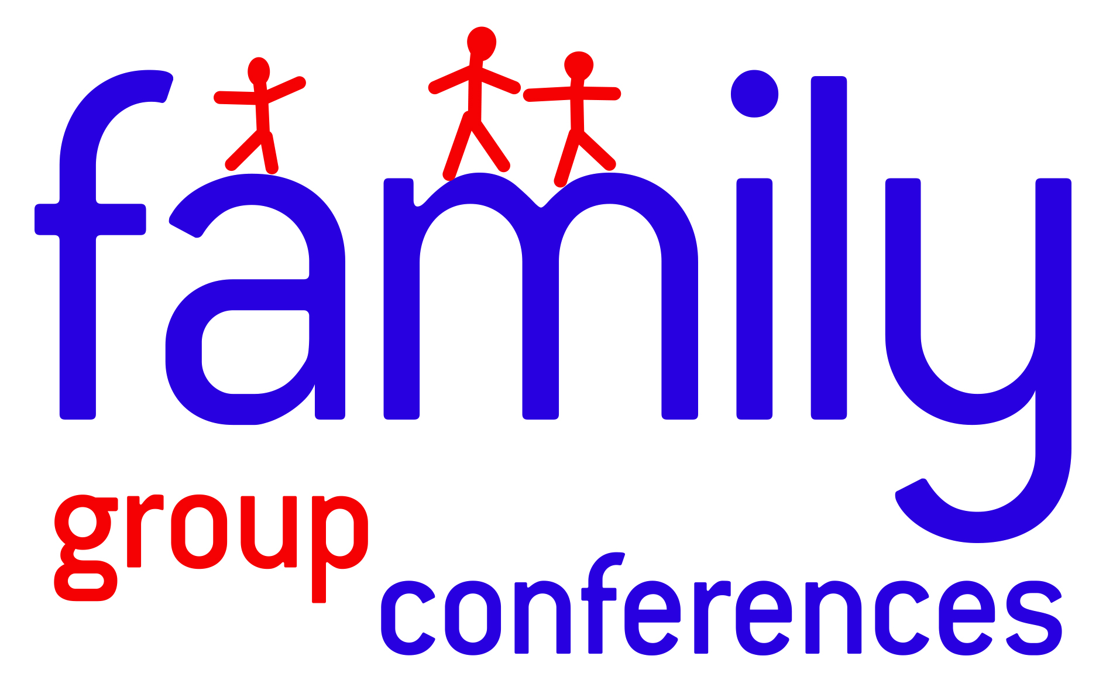FGC and Restorative Conferencing Briefing for Children’s Services staff | On behalf of :

Family Group and Restorative Conferences for West Berkshire

Context

FGCs and restorative conferences are a way of empowering families to meet together to draft and implement the best plan possible for children and young people. FGCs and Restorative conferences are solution-focused, decision-making processes with strength-based practice. They promotes the idea of collaborative decision-making, partnership, personal agency and active participation in the protection of children (Doolan, citing O’Donoghue, 2003).

FGC’s and restorative approaches often run alongside other service provision into the children and family’s life. The children may already be looked after, or may become so. They could be subject to care proceedings, child protection, or child in need processes. They may be offending, committing anti-social behaviour, becoming homeless, or been excluded from school. Many of these factors (and others) may apply. An FGC or restorative conference could improve things and/or work in combination with other input to support the children and their families.

An FGC or restorative conference can help to introduce a new element and encourage genuine change for families. There are a number of strengths in the process:

• It can engage a much wider family (and friends) group in considering how to meet the needs of the children
• The family often know themselves the best, so can often come up with new good ideas to improve things
• There is often a greater influence when extended family member are talking to each other, than when professionals are advising the parents
• Because the family members are the decision makers, the plans can often be more sustainable
• The process can increase the family’s sense of self worth and resilience, giving an improved prognosis for the future
• The family can often ‘own’ a plan much more because they have created it
• There is a ‘natural’ monitoring of the progress by the family members

West Berks. Provision

West Berks. is currently developing its use of Restorative Approaches across Children’s Services and will be working over the coming year to embed approaches into ‘business as usual’ across services. With regard to restorative approaches, it is intended that approaches will be delivered at 3 levels of Intensive and fidelity.

FGC Intensive

FGC Intensive will be delivered in line with existing arrangements regarding the use of FGC. However, referrals will be received via RAISE. Referrals and recording of FGC processes will then occur via RAISE.

FGC Intensive Criteria

FGC Intensive
Focus of Intervention/criteria
CP or CIN cases with three or more Risk of care and Custody Indicators | - DV as a feature within the family home  - Neglect as a feature with the family home  - Substance misuse as a feature within the family home  - Mental health as a feature within the family home  - CSE and Missing  - Offending behaviour as a feature within the family home  - Parents Previously LAC  - School Exclusions and EOTAS  - Family living in Poverty/in receipt of benefits  - At risk of homelessness
ICPC cases | - All ICPC cases where neglect is the primary category for CP registration should be considered for FGC intensive in order to support timely decision making for children and sustained outcomes
PLO Pre-proceedings | - Family subject to pre-proceedings intervention under PLO  - Permanency/Kinship
Section 20 Looked After | - Re-unification as part of the current care plan  - 16/17 year olds close to becoming homeless.  - Child unable to return home- no family carers identified.  - Parents try to relinquish responsibility- need to explore friends & family carers.  - Family breakdown
Youth Offending | - At risk of custody-Pre-sentence (custody threshold case) or currently subject to ISS.  - Long term repeat offender and /or assessed as Intensive.  - Wilful and persistent non compliance with a Court Order.
CSE and Missing | - High risk CSE and frequent Missing persons cases
Troubled Families cases | - TF cases where five or more of the national criteria have been met  1.Parents or children involved in crime or anti-social behaviour.  2. Children who have not been attending school regularly.  3. Children who need help: children of all ages, who need help, are identified as in need or are subject to a Child Protection Plan.  4. Adults out of work or at risk of financial exclusion or young people at risk of worklessness.  5. Families affected by domestic violence and abuse.  6. Parents or children with a range of health problems.

Restorative conferencing-Enhanced and Restorative Practice-Standard

Restorative conferencing Enhanced will be delivered in line with staff who have been trained to level 3 conferencing standard within West Berks. Enhanced Restorative Conferencing will formulate a central component to embedding restorative approaches across services within West Berks. Independence will be sought by teams delivering restorative conferencing for cases within other teams or internally by staff delivering restorative conferencing/family meetings for colleagues in relation to their caseload.

The Enhanced co-ordinator would only be involved for the duration of the restorative approach being planned and taking place. The Enhanced Co-ordinator would not have direct involvement with the families outside of this and the model will facilitate that family plans are aligned with the statutory plan and reviewing processes-Review Children Protection Conferences, Core Group Meetings, CIN reviews, TAF reviews. It is anticipated that the family plan will become integrated with the statutory plan in order to support working in partnership and family ownership over change.

Restorative Practice Standard will continue to develop with regard to embedding Restorative approaches as ‘business as usual’ in children’s services frameworks and planning processes.

Restorative Conferencing Enhanced Criteria

Restorative Conferencing Enhanced
Focus of Intervention
Prior to CIN or CP review | - FGC Enhanced can be used where:  - Progress with the current plan is limited  - Risk is not reducing regardless of intervention  - Further support is required to engage the whole family in planning and intervention for children and young people  - Professional and/or family feel that intervention has been exhausted and is no longer effective  - ‘Stuck’ or complex cases regarding case direction and interventions
Early help cases with Risk of care and Custody Indicators | - DV as a feature within the family home  - Neglect as a feature with the family home  - Substance misuse as a feature within the family home  - Mental health as a feature within the family home  - CSE and Missing  - Offending behaviour as a feature within the family home  - Parents Previously LAC  - School Exclusions and EOTAS  - Family living in Poverty/in receipt of benefits  At risk of homelessness
Strengths based criteria | - Where the professional network identifies that there are significant others or a potential family, friends, community network that should be consider regarding the family plan and ongoing intervention
Early help cases where step up is considered or where cases have stepped down from localities | - Early help cases where threshold for statutory services is considered or case has previously been open to localities
Youth Offending | - Young person assessed as Enhanced or Intensive (YJS Scaled Approach), where the above Intensive FGC criteria is not met.
EWS and Exclusions Officer | - Risk of Exclusion  - Poor school attendance  - Children on part time educational timetables/provision
Troubled Families cases | TF families where four or more of the national criteria have been met  1.Parents or children involved in crime or anti-social behaviour.  2. Children who have not been attending school regularly.  3. Children who need help: children of all ages, who need help, are identified as in need or are subject to a Child Protection Plan.  4. Adults out of work or at risk of financial exclusion or young people at risk of worklessness.  5. Families affected by domestic violence and abuse.  6. Parents or children with a range of health problems.

How to Refer

The primary referrers to The FGC/restorative conferencing Service will be Children’s Social Care, Youth Offending Service and those professionals working in the wider Children’s Services who carry particular responsibility for the welfare of children.

Below is a step by step guide for referrals via RAISE.

For more information please do not hesitate to contact Michael O’Connor on michael.oconnor@westberks.gov.uk or 07342 081001.

Process map and quick reference guide for FGC and Restorative Conferencing (RC) procedure West Berks

Steps |  | Timescale | Actions |  | Issues/recommendations
1 | FGC/ RC Referral completed by SW/FSW/Early help worker and agreed with family |  | Allocated worker to discuss the referral with the family and line manager. |  | Referral to be completed on RAISE and Restorative Practices Development Lead notified via RAISE reporting  Referral document found in Referrals section on RAISE
2 | Restorative Practices Development Lead QA's referral and decides on level of intervention-Intensive or Enhanced offer | Within 2 days of referral | QA of referral |  | Disagreement of threshold for intensive or enhanced offer or where case is not deemed suitable
3 | Case allocation | Within 2 days of referral | Case to be allocated to an FGC co-ordinator for Intensive cases-via Business support or a restorative conferencing trained member of staff for Enhanced cases-Via Restorative Practices Development Lead. Secondary allocation on RAISE |  | Capacity at Intensive is limited. Allocation at Enhanced will require discussion with team managers to determine capacity for time limited piece of restorative work
4 | FGC/Restorative conference preparation | Within 15-20 working days | FGC co-ordinator or restorative conferencing trained member of staff will use the FGC/Restorative conference preparation template when meeting with family members/extended network and consider family goals |  | FGC co-ordinators will not be able to complete this directly on RAISE and will therefore need to be uploaded as an attachment. Restorative conferencing trained staff may not have capacity to complete on RAISE and therefore may wish to upload as an attachment.
5 | FGC/Restorative Conference | Within 20 days of allocation | Conference takes place and attendance is updated on Conference attendance episode |  | Family plan is created and Goal Based Outcomes framework is considered to support families with measuring progress and change. Nominated family member to support review of plan is identified.
6 | Family Plan created | Within 5 days from conference | Family plan is written up by allocated FGC co-ordinator/Restorative conferencing trained member of staff and sent to the allocated case holder and FGC business support |  | Allocated worker to upload plan as an attachment in RAISE for Intensive FGC. Allocated Enhanced worker to write up plan in documents on RAISE.
7 | Exit FGC/Restorative Conferencing service | Upon completion of plan | Secondary allocation of FGC/restorative conferencing member of staff to be closed on RAISE by Business Support Officer -
8 | FGC/Restorative Conference Plan to be discussed at next statutory/early help review | Next available review | Discussion regarding Family led plan (lead by nominated family member from conference), focus of intervention going forward and professionals involved from the team and wider network
 | SW/ referring team
 | FGC/restorative approaches virtual service
 | Secondary allocated FGC coordinator/internal Restorative conferencing member of staff
Referrers will be expected to support and attend the FGC/ restorative conference process and will be required to ensure that co-ordinators have up to date information (via the referral form) to be able to contact you to discuss the progress of the case.

